Planeshift Preview: Hull Breach
Brian Kibler
See what Aaron Forsythe thinks.
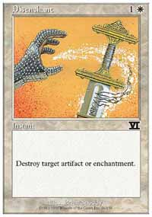
One card that has been a longtime staple in tournament Magic is Disenchant. Since the earliest days of Magic, Disenchant has been heralded as one of the most important cards in the game, not due to its raw power or game swinging effect, but because of its tremendous versatility and efficiency. The ability to remove any artifact or enchantment from play at the low cost of 1W is one that has earned Disenchant a place in countless tournament decks over the years, and will likely continue to do so for years to come.
Sometimes, though, Disenchant simply isn't enough. Particular metagames call for more powerful options than Disenchant can offer, and this often means sacrificing versatility for raw power. Examples of this exist across the board in Magic, as more flexible cards pay for their options with higher mana costs or weaker effects. To see this, one needs only to compare Creeping Mold to Splinter and Tranquility, or Disenchant to Peace and Quiet and Dust to Dust. The more focused cards have significantly more powerful effects in those situations where they are applicable, but suffer from an inability to deal with other kinds of permanents. Because of this, players often find themselves faced with the unattractive options of either relying on more versatile, less powerful answers to diverse classes of threats, or packing their sideboards full of focused hate.
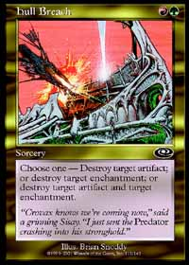
No longer. Planeshift's Hull Breach offers the best of both worlds, as it is not only extremely versatile but also potentially a very powerful card. For all intents and purposes, Hull Breach can do anything Disenchant can do, although as a Sorcery rather than at Instant speed, and on top of that, it can mimic the card advantage capabilities of more focused cards like Rack and Ruin and Dust to Dust. Combine all of this with an amazingly low mana cost of RG, and you have a card that will easily find its way into Constructed decks in no time.
To see just how much of an impact Hull Breach stands to make on the Standard format, one should take a quick look at the popular archetypes in the current environment. The first and most prevalent deck - and the primary contender for the inclusion of Hull Breach somewhere in its construction - is Fires. The simple fact that this deck is named for an enchantment is the first hint that Hull Breach may be useful against it, but with further analysis, the applications become even more impressive. Standard versions of this decktype include Fires of Yavimaya, Saproling Burst, and Chimeric Idol as potential targets for Hull Breach, with some designs including Armadillo Cloak as an additional target. Hull Breach can not only destroy Fires of Yavimaya early in the game before it can have an impact because of it's low cost of GR, but in the mid to late game, it can have the devastating effect of removing both an opposing Saproling Burst and Chimeric Idol.
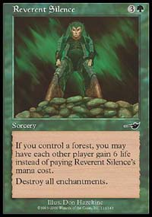
The second deck against which Hull Breach will find considerable use is Rebels. Against standard monowhite Rebel designs, a green/red deck very much wants to have a way to destroy Parallax Wave and Crusade. Unfortunately, narrow enchantment removal cards like Reverent Silence and Calming Verse, as played by Zvi Moskowitz and Rob Dougherty in their Pro Tour Chicago decks, are generally far from ideal in the matchup, as they deal only with a very specific class of permanent and are thus inherently reactive. Hull Breach, on the other hand, is not only less expensive than either of the enchantment sweeper effects (barring the alternative casting cost of Reverent Silence), thus allowing the green/red player more leeway with the use of his or her mana on the turn it is cast, but it is also, again, far more versatile. The ability to cheaply remove a single Parallax Wave, Crusade, or Chimeric Idol in the early game can be very important, and, just like against Fires, can destroy both one of the white enchantments as well as an Idol in the mid to late game.
Starting to sound familiar? Take a look at another popular archetype in standard, U/W control. Many U/W control decks run either Story Circle or Teferi's Moat, and almost all play with Tsabo's Web. Tsabo's Web, because of its nature as a cantrip card, is a very unattractive target for removal effects due to the inherent card disadvantage involved, but can be a significant annoyance to a player with a number of affected lands in play. Hull Breach allows a green/red player not only the opportunity to destroy potential Story Circles and Teferi's Moats, as well as taking out a Tsabo's Web almost as an afterthought, but due to its versatile nature can be brought in from the sideboard to deal with even the threat of enchantments. Even if they are not present, Hull Breach will rarely be a dead card, as it can be used to take out a Web if the need arises.
All in all, Hull Breach looks to be card that will make a significant impact on the Standard environment. It will not be the sort of card that has players screaming for the head of R&D, nor will it spawn any new archtypes by its presence. It will, however, quietly find its way into a number of decks, and will serve those decks well in their times of need. Where once player were forced to dip into white for the versatility of Disenchant, now G/R mages have their own universal answer, and one with an additional powerful effect to boot. Be afraid. Be very afraid.
For information about Planeshift Prereleases, click here.

